**TECH-A-INTERN : INTERNSHIP OF UX/UI DESIGN DOMAIN**

**NAME : DHANESHWARI SURAJMAL JATOLIA**

**TASKS : LEVEL 2**

**DESIGN A MOBILE APPLICATION**

**THE THEME BEHIND CREATING WAS VERY MUCH DECENT AND EYE CATCHY WITH THE USE OF OLNY TWO COLOURS WITH COVERING ALL THE NECESSARY FRAMES WHICH NEENDED IN IT.**

**1.SPLASH SCREEN**

** **

**VIDEO CLIP IS THERE……….**

**2.LOGIN PAGE**

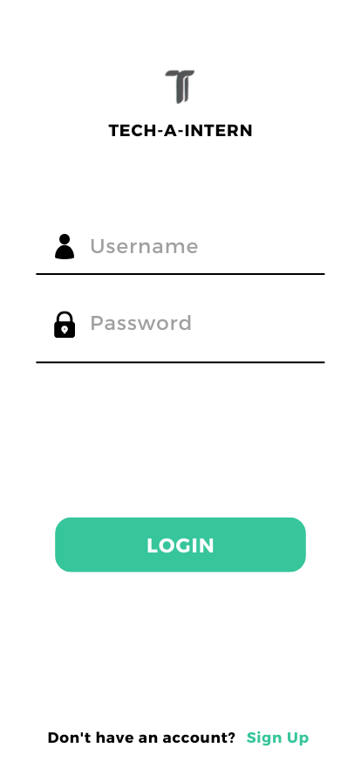

**3. TAKING INFORMATION IF NOT HAVE THE ACCOUNT**

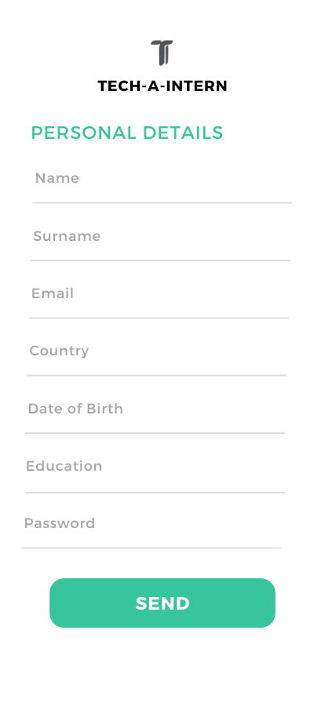

**4. WELCOMING FRAME WITH TOGGLE MENU**

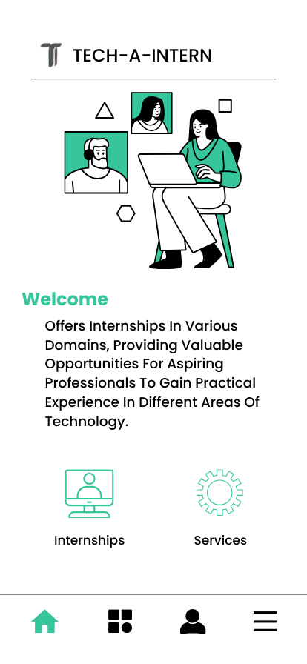

**5.INTERSHIP SCREEN FRAME**

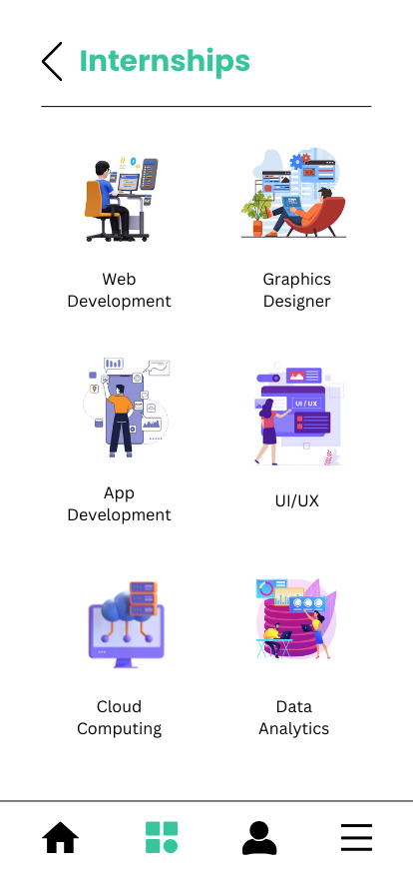

**6.PROFILE WHERE YOU CAN EDIT YOU INFORMATION**

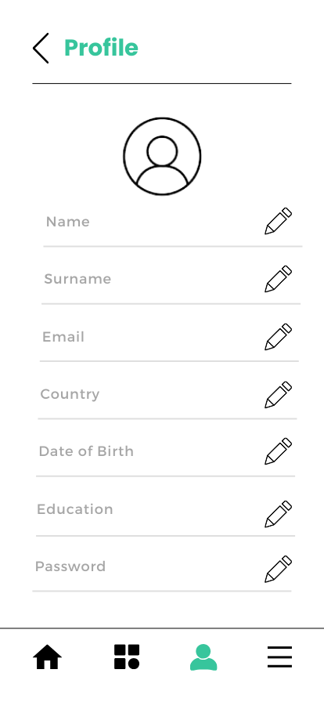

**7.HERE IS THE TOGGLE MENU**

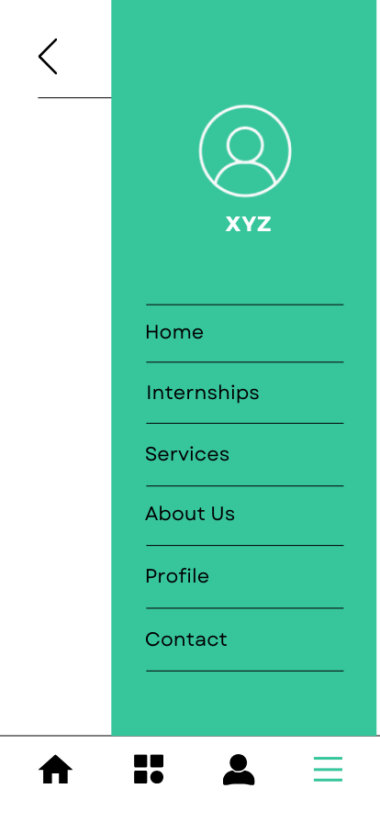

**8.SERVICES FRAME**

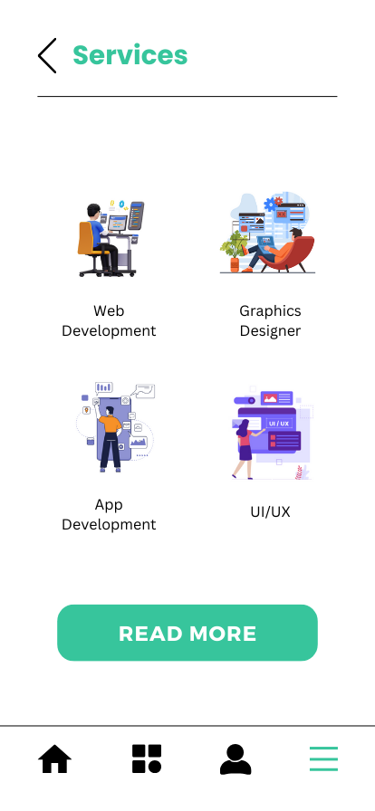

**9.ABOUT TECH-A-INTERN**

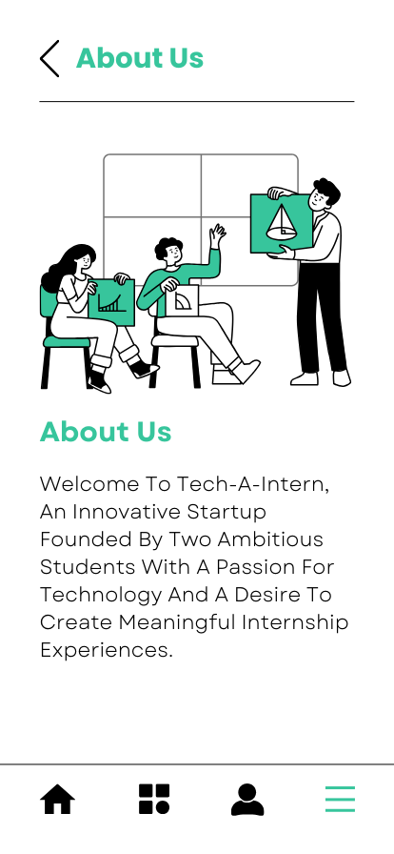

**10.CONTACT FRAME**

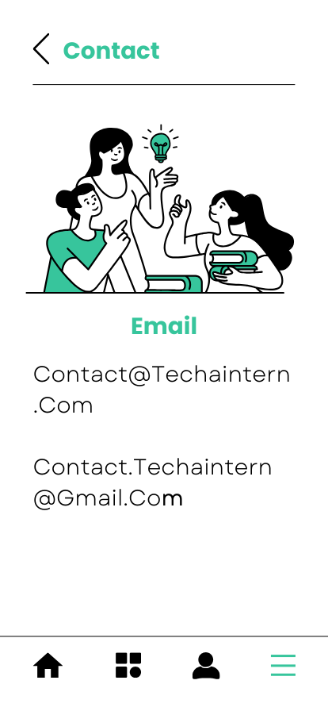

**THANK YOU.**